**Assignment 4 Part 2:**  **Analytic Functions**

## Query 1: Ranking within the entire result

SELECT name,

SUM(ExtCost) AS Sum_Extended_Cost,

RANK() OVER ( ORDER BY SUM(Extcost) DESC ) AS Sum_ExtendedCost_Rank

FROM mmannino.cust_vendor_dim c, mmannino.inventory_fact i

WHERE i.CUSTVENDORKEY = c.CUSTVENDORKEY

AND Transtypekey = 5

GROUP BY c.name;

**Output :**

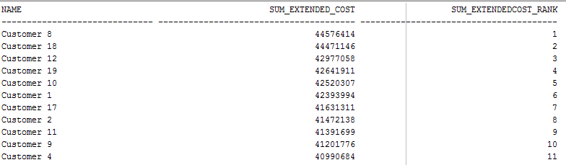

**Query 2: Ranking within a partition**

SELECT name,state,

SUM(ExtCost) AS Sum_Extended_Cost,

RANK() OVER (PARTITION BY state ORDER BY SUM(Extcost) DESC) AS SalesRank

FROM mmannino.cust_vendor_dim c, mmannino.inventory_fact i

WHERE i.CUSTVENDORKEY = c.CUSTVENDORKEY

AND Transtypekey = 5

GROUP BY c.name, c. state

ORDER BY c.state;

**Output:**

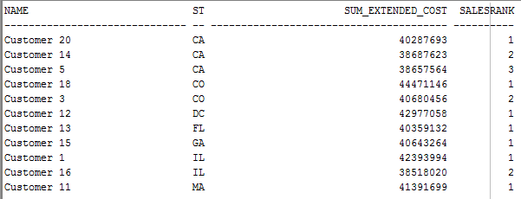

## Query 3: Ranking and dense ranking within the entire result

SELECT name,COUNT(*) AS RowCount,

RANK() OVER (ORDER BY COUNT(*) DESC) CountRank,

DENSE_RANK() OVER (ORDER BY COUNT(*) DESC) CountDenseRank

FROM mmannino.cust_vendor_dim c, mmannino.inventory_fact i

WHERE i.CUSTVENDORKEY = c.CUSTVENDORKEY

AND Transtypekey = 5

Group BY c.name;

**Output :**

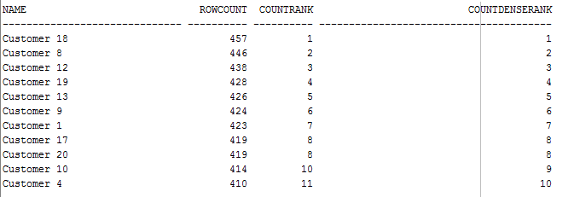

## Query 4: Cumulative extended costs for the entire result

SELECT zip,calyear,calmonth,

SUM(ExtCost) AS Sum_Extended_Cost,

SUM(SUM(ExtCost)) OVER

(ORDER BY zip,calyear,calmonth

ROWS UNBOUNDED PRECEDING ) AS CumSum_ExtendedCost

FROM mmannino.cust_vendor_dim c, mmannino.date_dim d,mmannino.inventory_fact i

WHERE c.custvendorkey = i.custvendorkey

AND d.datekey = i.datekey

AND Transtypekey = 5

GROUP BY c.zip,d.calyear,d.calmonth;

**Output:**

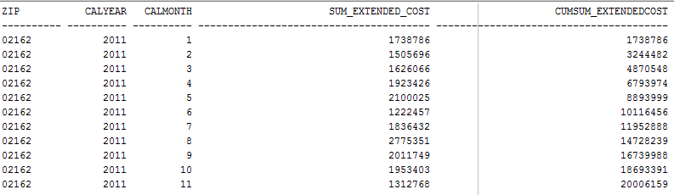

## Query 5: Cumulative extended costs for a partition

SELECT zip,calyear,calmonth,

SUM(ExtCost) AS Sum_Extended_Cost,

SUM(SUM(ExtCost)) OVER

(PARTITION BY zip,calyear ORDER BY zip,calyear,calmonth

ROWS UNBOUNDED PRECEDING ) AS CumSum_ExtendedCost

FROM mmannino.cust_vendor_dim c, mmannino.date_dim d,mmannino.inventory_fact i

WHERE c.custvendorkey = i.custvendorkey

AND d.datekey = i.datekey

AND Transtypekey = 5

GROUP BY c.zip,d.calyear,d.calmonth;

**Output :**

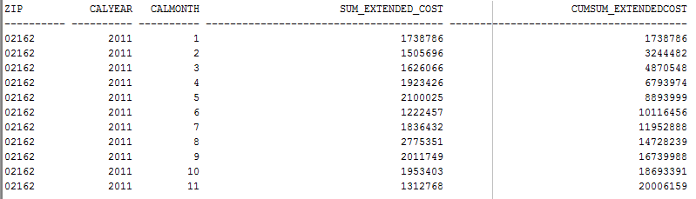

## Query 6: Ratio to report applied to the entire result

SELECT seconditemid,

SUM(ExtCost) AS Sum_Extended_Cost,

To_Char(RATIO_TO_REPORT(SUM(ExtCost))

OVER ()) AS SumExtendedCost_Ratio

FROM mmannino.item_master_dim im, mmannino.inventory_fact i

WHERE im.itemmasterkey = i.itemmasterkey

AND Transtypekey = 1

GROUP BY im.seconditemid

ORDER BY SUM(Extcost) DESC;

**Output:**

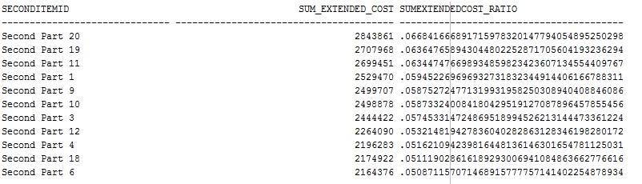

## Query 7: Ratio to report applied to a partition

SELECT calyear,seconditemid,

SUM(ExtCost) AS Sum_Extended_Cost,

To_Char (RATIO_TO_REPORT(SUM(ExtCost))

OVER (PARTITION BY calyear)) AS SumExtendedCost_Ratio

FROM mmannino.date_dim d,mmannino.item_master_dim im, mmannino.inventory_fact i

WHERE d.datekey = i.datekey

AND im.itemmasterkey = i.itemmasterkey

AND Transtypekey = 1

GROUP BY d.calyear,im.seconditemid

ORDER BY d.CALYEAR ASC, SUM(Extcost) DESC;

**Output:**

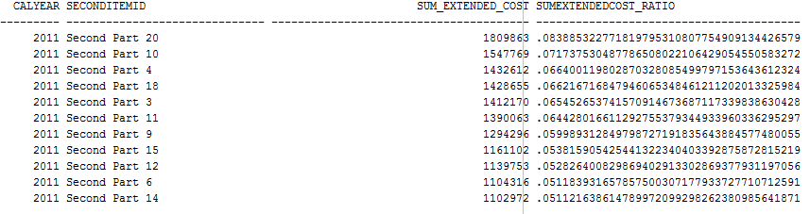

## Query 8: Cumulative distribution functions for carrying cost of all branch plants

SELECT bpname,CompanyKey, CarryingCost,

RANK() OVER (ORDER BY CarryingCost) As Rank_CarryingCost,

PERCENT_RANK()

OVER (ORDER BY CarryingCost) As PercentRank_CarryingCost,

ROW_NUMBER()

OVER (ORDER BY CarryingCost) As RowNum_CarryingCost,

CUME_DIST()

OVER (ORDER BY CarryingCost ASC) As CumDist_CarryingCost

FROM MMANNINO.branch_plant_dim;

**Output:**

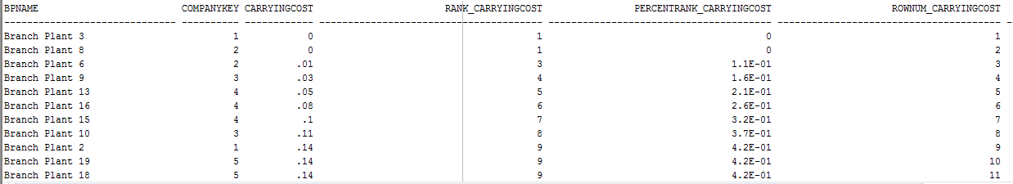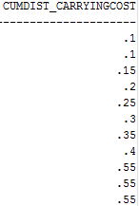

## Query 9: Determine worst performing plants

SELECT bpname,CompanyKey, CarryingCost, CumDist_CarryingCost

FROM ( SELECT bpname,CompanyKey, CarryingCost,

CUME_DIST()

OVER (ORDER BY CarryingCost ASC) As CumDist_CarryingCost

FROM MMANNINO.branch_plant_dim )

WHERE CumDist_CarryingCost >= 0.85;

**Output :**

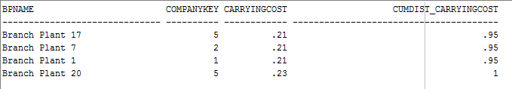

## Query 10: Cumulative distribution of extended cost for Colorado inventory

SELECT DISTINCT Extcost,

To_Char(CUME_DIST() OVER (ORDER BY Extcost))

As CumDist_ExtCost

FROM mmannino.cust_vendor_dim c, mmannino.inventory_fact i

WHERE c.custvendorkey = i.custvendorkey

AND c.state = 'CO'

ORDER BY Extcost;

**Output :**

